SCREEN SPECIFICATION
1. Screen transition diagram
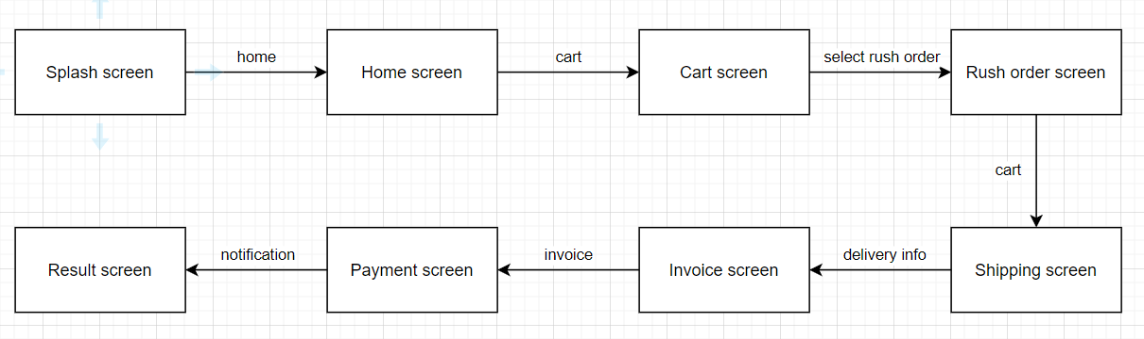
2. Figma link: https://www.figma.com/file/ism6aqDK1ssfG5Xxeijam9/AIMS-Project?type=design&node-id=0%3A1&mode=design&t=XkRQqgvD4VGkslMx-1
3. Screen specifications for all screens
a. Splash screen
AIMS Software |  | Date of creation | Approved by | Reviewed by | Person in charge
Screen specification | Splash screen | 6/4/2024 |  |  | Dinh Viet Quang
 |  | Control | Operation | Function
 |  | Area for displaying AIMS logo | Initial | Displaying AIMS logo

b. Home screen
AIMS Software |  | Date of creation | Approved by | Reviewed by | Person in charge
Screen specification | Home screen | 6/4/2024 |  |  | Dinh Viet Quang
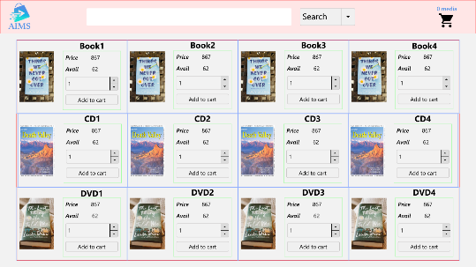 |  | Control | Operation | Function
 |  | Area for displaying search content | Initial | Display the search content
 |  | Search button | Click | Search for items which have properties matching with search content
 |  | Area for displaying number of medias in cart and cart icon | Click | Navigate to cart screen
 |  | Area for displaying items in the shop | Initial | Display the items in the shop
 |  | Area for displaying item information | Initial | Display title, price, number of available products of that item and the amount of that item that user might want to add to cart
 |  | Arrow up button | Click | Increase the amount of item that user might want to add to cart
 |  | Arrow down button | Click | Increase the amount of item that user might decrease to add to cart
 |  | Add to cart button | Click | Add item to the cart

Screen name | Home screen
Item name | Number of digits (bytes) | Type | Field attribute | Remarks
Search content | 500 | Character | Black
Amount of item | 20 | Numeral | Black

c. Cart screen
AIMS Software |  | Date of creation | Approved by | Reviewed by | Person in charge
Screen specification | Cart screen | 6/4/2024 |  |  | Dinh Viet Quang
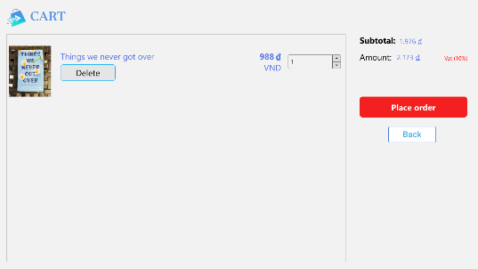 |  | Control | Operation | Function
 |  | Area for displaying the subtotal | Initial | Display the subtotal
 |  | Area for display items in the cart | Initial | Display the media with the corresponding information
 |  | Place order button | Click | Display the Delivery Form
 |  | Delete button | Click | Remove the item from the cart
 |  | Back button | Click | Return to previous screen

Screen name | Cart screen
Item name | Number of digits (bytes) | Type | Field attribute | Remarks
Media title | 50 | Character | Blue | Left-justified
Price | 20 | Numeral | Blue | Right justified
Subtotal | 20 | Numeral | Blue | Left-justified

d. Shipping screen
AIMS Software |  | Date of creation | Approved by | Reviewed by | Person in charge
Screen specification | Shipping screen | 6/4/2024 |  |  | Dinh Viet Quang
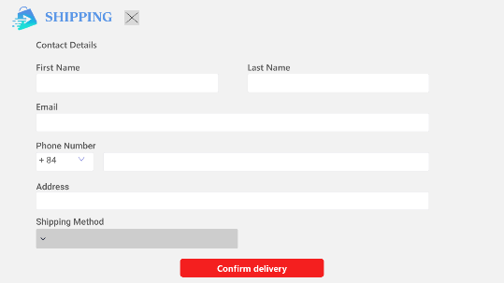 |  | Control | Operation | Function
 |  | Area for display customer information | Initial | Display some questions to request customer to fill
 |  | Confirm delivery | Click | Display the Invoice

Screen name | Shipping screen
Item name | Number of digits (bytes) | Type | Field attribute | Remarks
Name | 30 | Character | Black
Phone | 10 | Numeral | Black
Province/City | 50 | Character | Black
Address | 50 | Character | Black
Shipping method | 100 | Character | Black

e. Invoice screen
AIMS Software |  | Date of creation | Approved by | Reviewed by | Person in charge
Screen specification | Invoice screen | 6/4/2024 |  |  | Dinh Viet Quang
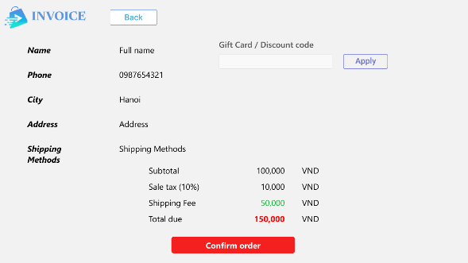 |  | Control | Operation | Function
 |  | Area for display order information | Initial | Display some order information
 |  | Area for displaying the subtotal | Initial | Display the subtotal
 |  | Area for displaying gift code | Initial | Display optional gift code section for customer to enter
 |  | Confirm to Order button | Click | Display the payment

f. Payment screen
AIMS Software |  | Date of creation | Approved by | Reviewed by | Person in charge
Screen specification | Payment screen | 6/4/2024 |  |  | Dinh Viet Quang
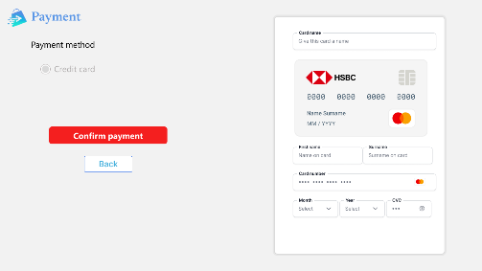 |  | Control | Operation | Function
 |  | Area for display customer’s card information | Initial | Display some question to request customer to fill
 |  | Choose payment method | Click | Display payment method that customer can choose (credit card is default)
 |  | Confirm payment | Click | Display the result
 |  | Back button | Click | Return to previous screen

Screen name | Payment screen
Item name | Number of digits (bytes) | Type | Field attribute | Remarks
Card name | 30 | Character | Black | Left-justified
Card number | 30 | Numeral | Black | Left-justified
First name | 30 | Character | Black | Left-justified
Surname | 30 | Character | Black | Left-justified
Date | 30 | Date | Black | Left-justified

g. Rush order screen
AIMS Software |  | Date of creation | Approved by | Reviewed by | Person in charge
Screen specification | Rush order screen | 6/4/2024 |  |  | Dinh Viet Quang
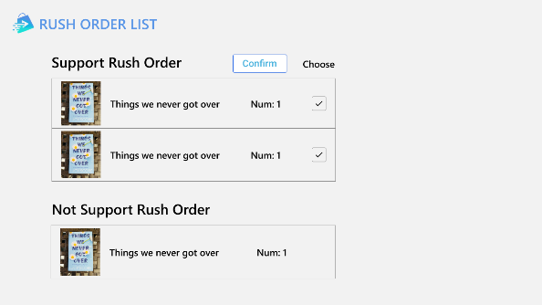 |  | Control | Operation | Function
 |  | Area for displaying rush order supported items | Initial | Display items that rush order supports
 |  | Area for displaying rush order unsupported items | Initial | Display items that rush order doesn’t support
 |  | Area for displaying item information | Initial | Display image, title, amount of that item
 |  | Item’s check box | Click | Select items that user wants to buy
 |  | Confirm button | Click | Confirm the rush order

h. Result screen
AIMS Software |  | Date of creation | Approved by | Reviewed by | Person in charge
Screen specification | Result screen | 6/4/2024 |  |  | Dinh Viet Quang
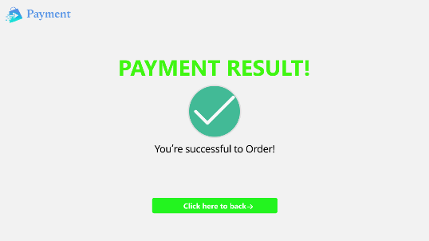 |  | Control | Operation | Function
 |  | Area for displaying result | Initial | Display purchase result
 |  | Button | Click | Return to home screen

